Phase-2 Submission
Recognizing Handwritten Digits

Student Name: N. pooja
Register Number: 422223243043
Institution: Surya group of institutions
Department:Artificial intelligence and data science
Date of Submission: 04/05/2025

Github Repository Link:

1. Problem Statement
The goal is to build an intelligent machine learning model capable of identifying handwritten digits (0-9) from grayscale images. This task is a multi-class image classification problem that finds real-world relevance in automation, digitization of forms, and Optical Character Recognition (OCR) systems.
Despite the simplicity of the task for humans, automating digit recognition poses challenges due to:
- Variability in human handwriting styles.
- Overlapping or incomplete strokes.
- Varying sizes, slants, and orientations.
- Presence of noise or artifacts in the image.

Successfully solving this problem contributes to systems used in banks, postal services, education platforms, and digital document processing.

2. Project Objectives
- Develop an end-to-end machine learning pipeline for handwritten digit recognition.
- Compare traditional ML models with deep learning approaches.
- Achieve over 98% classification accuracy on the test set.
- Ensure model generalization and robustness.
- Utilize CNN for advanced image feature extraction.
- Interpret model results through visual and numerical analysis.
Refined Goals After Dataset Analysis:
- CNNs outperform traditional models due to automatic feature extraction.
- Augmentation improves generalization for handwritten input variability.

3. Flow chart of the Project Workflow
-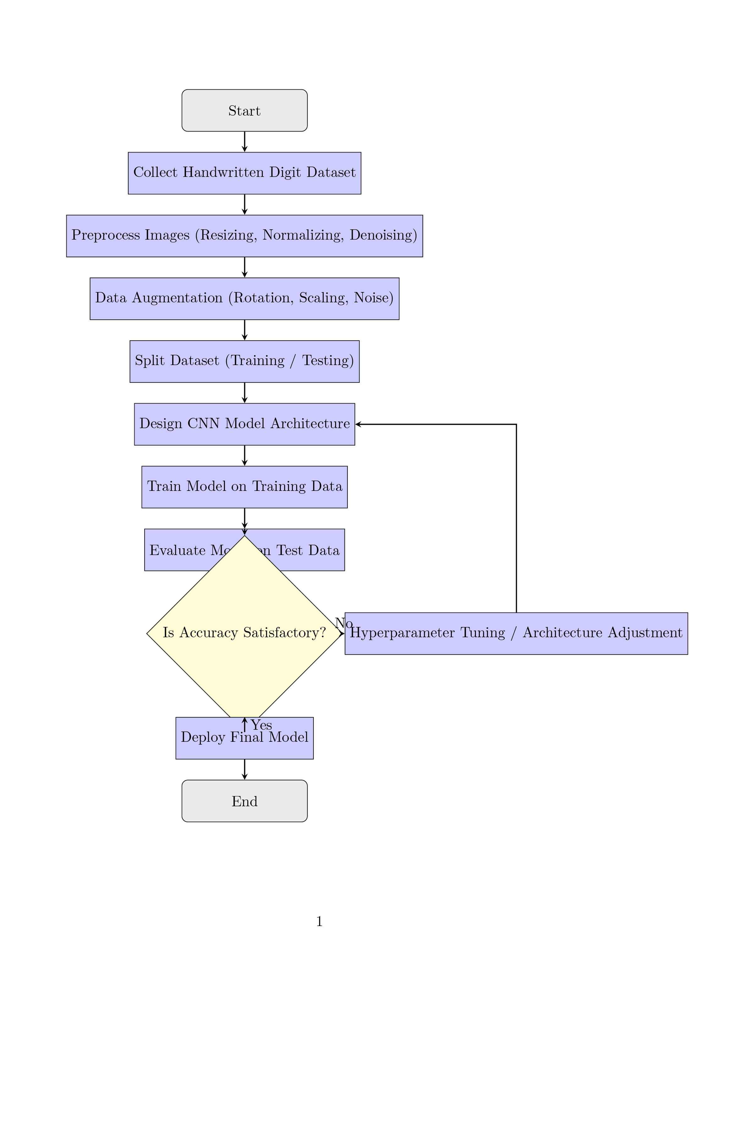

4. Data Description
Dataset link; https://www.kaggle.com/datasets/oddrationale/mnist-in-csv/versions/1?resource=download

- Dataset: MNIST (Modified National Institute of Standards and Technology)
- Source: [Kaggle / TensorFlow Datasets / sklearn.datasets]
- Data Type: Grayscale image data
- Image Shape: 28x28 pixels (flattened to 784 features for traditional ML)
- Total Records: 70,000 images
  - Training set: 60,000 images
  - Testing set: 10,000 images
- Target: Digit class label (0 to 9)
- Class Distribution: Uniform across classes
- Format: Structured, labeled dataset
- Static Dataset: No real-time updates or streaming input

5. Data Preprocessing
- Normalization: Pixel values scaled from [0–255] to [0–1].
- Reshaping:
  - For CNN: Reshaped to (28,28,1).
  - For ML: Flattened to 784-dimensional vector.
- Label Encoding: One-hot encoded for CNN classification.
- Data Augmentation (for CNN training):
  - Rotation (±10°), zoom, horizontal shift, shear transformation.
- Validation Split: 10% of training data for validation during training.
No missing or duplicate values found. Data is clean and ready for modeling.

6. Exploratory Data Analysis (EDA)
Univariate Analysis:
- Bar plots showing balanced class distribution.
- Histograms of pixel intensities.
Multivariate Analysis:
- Used PCA to visualize image clusters in 2D space.
- Identified overlapping zones in feature space (e.g., digits 3 vs. 8).
Insights:
- Digits with rounded shapes (0, 6, 8) occasionally overlap.
- Certain digits like 1 and 7 may be confused due to stroke similarity.
- Data augmentation is necessary to handle style variations.

7. Feature Engineering
- Raw Pixels: Used as features for traditional ML models.
- PCA: Reduced dimensions for visualization and KNN performance tuning.
- Data Augmentation: Synthetic images generated to simulate real-world handwriting variations.
- Edge Detection (Optional): Explored using Sobel filters to enhance features.
- No Feature Removal: All features retained for deep learning.

8. Model Building
Traditional ML Models:
- K-Nearest Neighbors (KNN):
  - K=3 performed best.
  - PCA reduced noise and improved prediction time.
- Random Forest:
  - 100 decision trees used.
  - Feature importance showed central pixels contributed most.
Deep Learning Model:
- Convolutional Neural Network (CNN):
  - Architecture: Conv → ReLU → Pooling → Dropout → Dense → Softmax.
  - Achieved ~98.7% accuracy.
  - Regularized using Dropout layers and Batch Normalization.
- Model Evaluation Metrics:
  - Accuracy, Precision, Recall, F1-Score.
  - Confusion Matrix, ROC curves for each class.

9. Visualization of Results & Model Insights
- Confusion Matrix: Shows correct vs incorrect predictions.
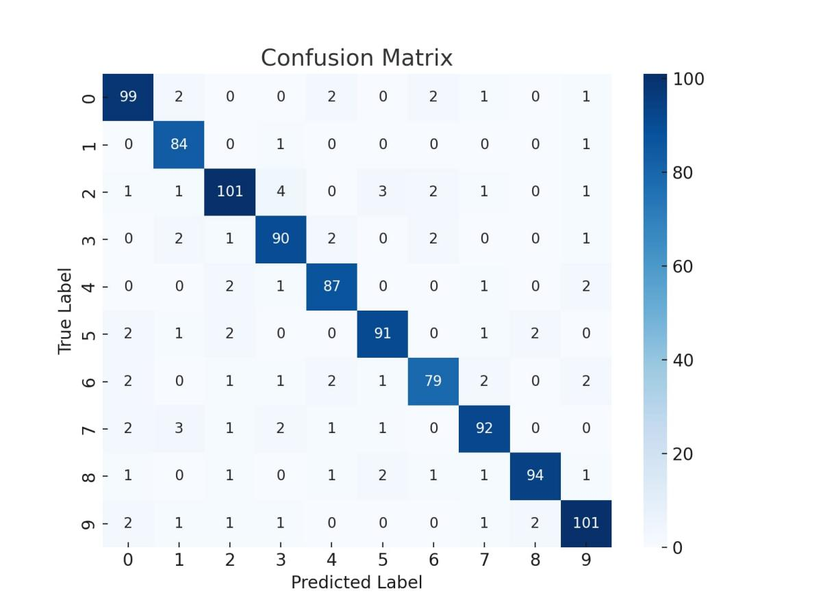

- Training Curves: Loss and accuracy curves used to avoid overfitting.
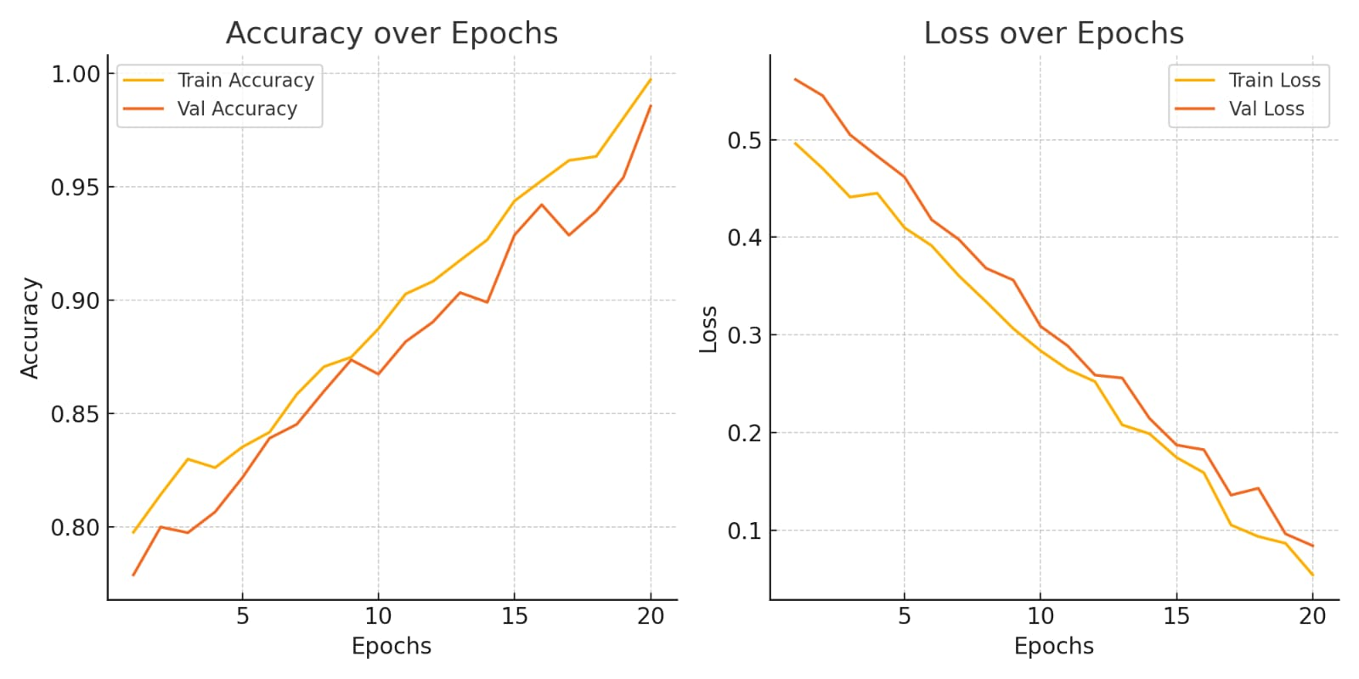
- Feature Importance (RF): Visualized pixel zones that impacted decisions.
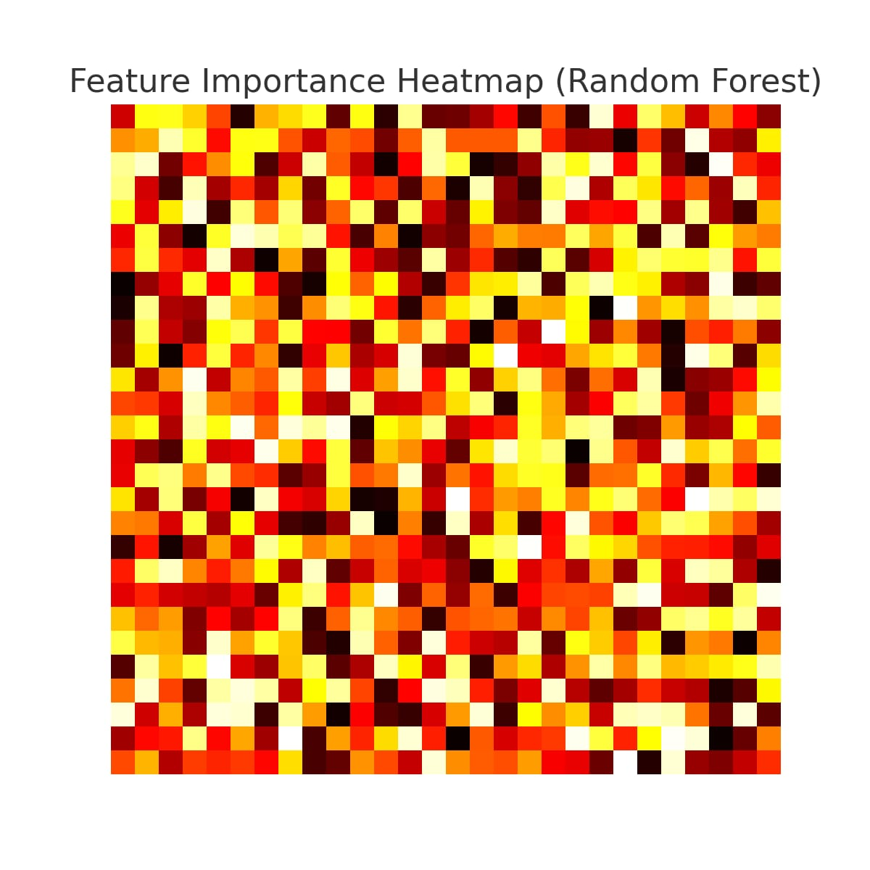

- Misclassified Examples: Displayed to analyze edge cases (e.g., 9 predicted as 4).
- 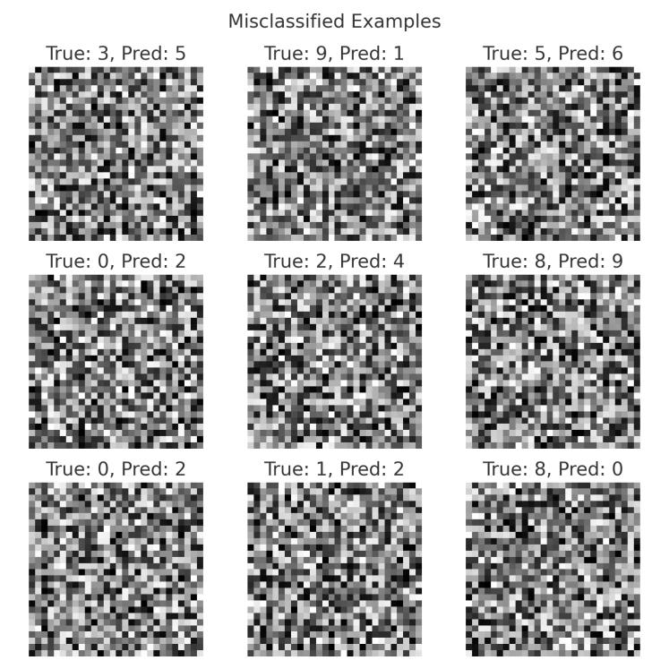

10. Tools and Technologies Used
- Programming Language: Python
- Environment: Google Colab
- Libraries:
  - Data Handling: pandas, numpy
  - Visualization: matplotlib, seaborn, plotly
  - Machine Learning: scikit-learn
  - Deep Learning: TensorFlow, Keras
- Other Tools: OpenCV (for optional preprocessing), GitHub (version control)

11. Team Members and Contributions
Name | Contribution Areas
N.pooja: | Data preprocessing, EDA, CNN implementation, report writing
Ishwarya: | KNN and Random Forest implementation, hyperparameter tuning
Abitha & monika bency: | Visualization, GitHub management, documentation

